|  |  |  |
| --- | --- | --- |
|  |  | A simple Bank system  User manual |

## Application Scenario

The system offers three types of account:

1. **Saver Account**: For Junior and Saver accounts, no withdraw more funds than their limit permits.
2. **Junior Account**: Only customers under the age of 16 may open a Junior account
3. **Current Account**: A customer may withdraw additional funds, up to, but not exceeding, their overdraft limit.

Each account has a unique account number. A customer is also issued a separate personal identification number (PIN) for that account.

**Currently, the system** **doesn’t offer functions to:**

1. **register a customer**.

If you want to add a customer, please add your information into the file “BankSystem/src/File/CreditAgency.txt” in format (name,address,birth,credit).

1. **change PIN/ overdraft limit or other details of your account**.

If you want to change the them, please find the corresponding line in the file “BankSystem/src/File/Accounts.txt” and change it by yourself in format (accID,type,PIN,balance,overdraftlimit,clearing,account_status,noticed)

If you have trouble in finding your account detail (forgetting the account ID), please check the file “BankSystem/src/File/AccountFinder.txt” and find.

more details of the text file: please see “BankSystem/Readme.txt”

## Development Environment

1. **IDE**: IntelliJ IDEA 2019.1 (Ultimate Edition)
2. **JRE**: 1.8.0_202-release-1483-b39 x86_64
3. **JVM**: OpenJDK 64-Bit Server VM by JetBrains s.r.o
4. **Operating System**: macOS 10.14.4
5. **Project SDK**: 11

## Copyright

© 2019 👤 Xi XIA

## Functions

The Bank System offers 6 functions. Home page is shown as Fig. 1

Figure 1. Bank System home page

1. **Open Account**

In order to open an account, the customer must provide the following information: $= 1 \backslash * GB3 ①$ name, ② address, ③ date of birth, ④ type of account to be opened. shown as Fig 2.

Figure 2. Open Account page

Note:

1. Only customer with satisfactory credit history can open an account
2. Only customers under the age of 16 may open a Junior account
3. All current accounts’ overdraft limit is set as 2000
4. When opening an account, the PIN is set the same as the customer’s birthday.
5. All kinds of invalid input (unregistered customer, wrong information of a registered customer, customer has an unsatisfactory credit history, customer over 16 years old attempts to opens a Junior account, account type is not the type we offer – saver/junior/current,) will get the same notice shown as Fig.2. Close the Invalid Input Notice window, you can continue other operations in the previous Page.

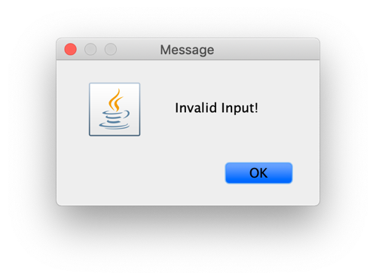

Figure 3. Invalid Input Notice

1. Typo mistake is not allowed including lower/uppercase mistake.
2. **Deposit Funds**

The depositor should provide $= 1 \backslash * GB3 ①$ an account number, ② the amount to be deposited

When funds are deposited, they are either cleared (the funds have been fully credited, e.g. Cash), or un-cleared (transfer of funds is pending, e.g. using Cheque). Cleared funds are immediately credited to the account.

1. **Clear Funds**

An external bank clearing system periodically clears un-cleared funds. Once cleared, they are immediately credited to the account. Customers can credit uncleared funds to an account by entering $= 1 \backslash * GB3 ①$ appropriate account number and ② PIN .

1. **Withdraw Funds**

Customers may withdraw funds from an account by supplying $= 1 \backslash * GB3 ①$ their account number, ② an appropriate identification (in this case, their PIN), and ③ the amount to be withdrawn. A customer cannot withdraw more funds than their limit permits (determined by the type of account).

For a withdrawal from a Saver account, a minimum period of notice (in days) must be given before any withdrawal can be made. Here we haven’t define the days required to notice, you can simply click on the button “Notice” to give a notice before withdrawal.

1. **Suspend Account**

In some situations, accounts may be suspended and no further transactions may occur until the account is re-instated. Customers can suspend an account by entering $= 1 \backslash * GB3 ①$ appropriate account number and ② PIN .

1. **Close Account**

A customer can choose to close their account provided that the balance has been cleared. Customers can close the cleared account by entering $= 1 \backslash * GB3 ①$ appropriate account number and ② PIN .